Web Automation Setup

Required Tools:

1. Java Installation
2. Eclipse Installation
3. Automation code checkout from GITHUB
4. Automation Project setup in eclipse
5. How to run Automation code

Follow below steps to set up the automation code in the windows machine.

# Java Installation :

Step 1: Go to site <https://www.oracle.com/java/technologies/downloads/>

Select Windows

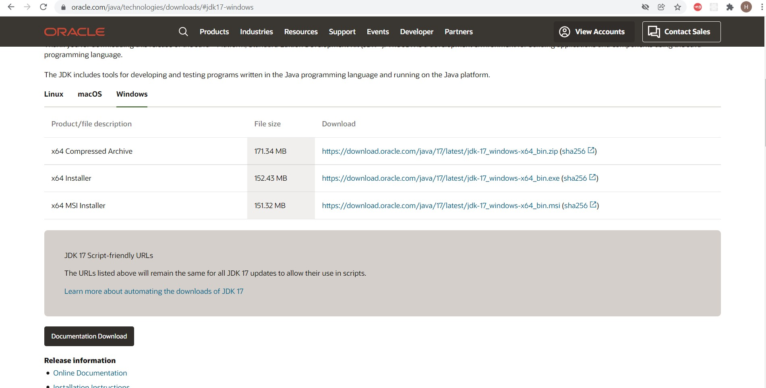Click on link related to x64 Installer

Note:After Downloading. Click on the installer file and follow the instructions below

## Step 2: Click on “Next”

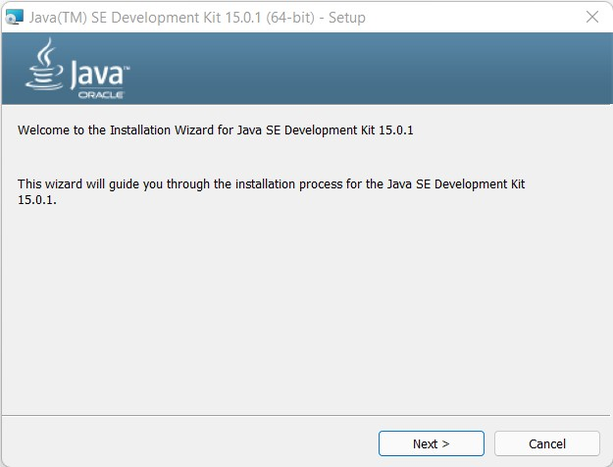

Step 3: Change the installation folder if required and Click on Next

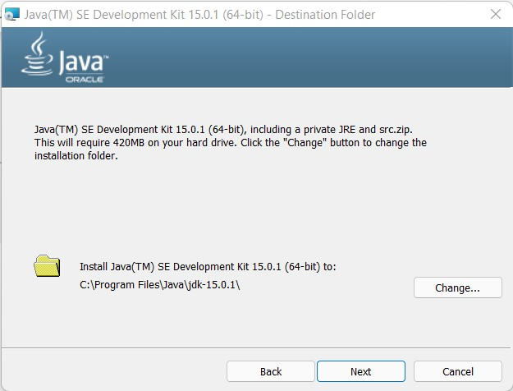

Step 4: Wait for installation, once it install click on “Close”

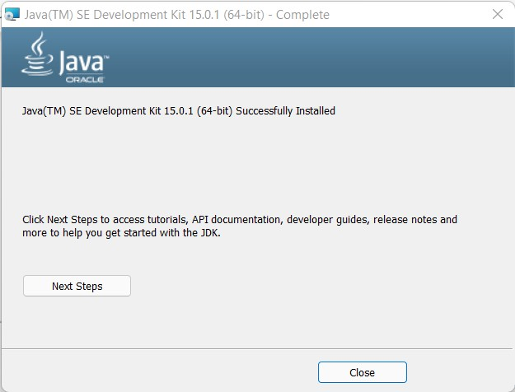

Step 5:Go to the Installation folder. Default folder : C:\Program Files\Java\jdk-<version>\bin

1. Copy the java bin path as shown in above figure.

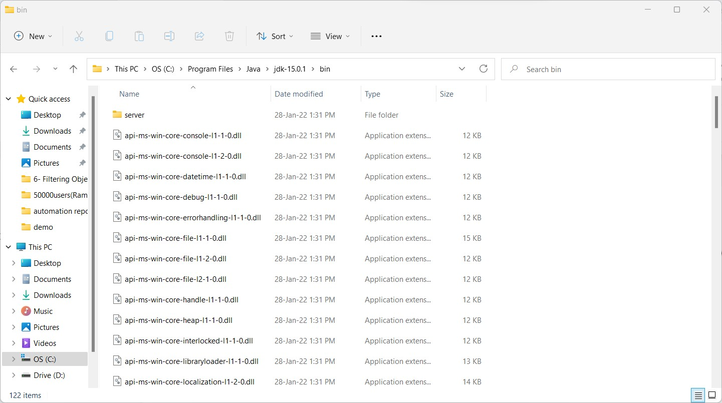

## Step 6: Search for System environment variables in the windows search panel.

Below the window will appear, click on Environment Variables.

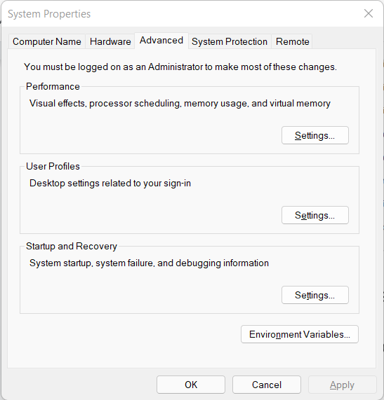

## Step 7:In the System Variables window select path and click on Edit.

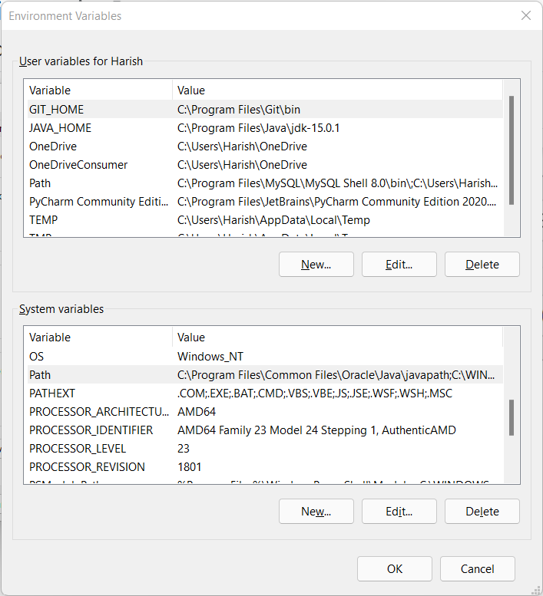

Step 8: Click on new and paste the copied java path until bin

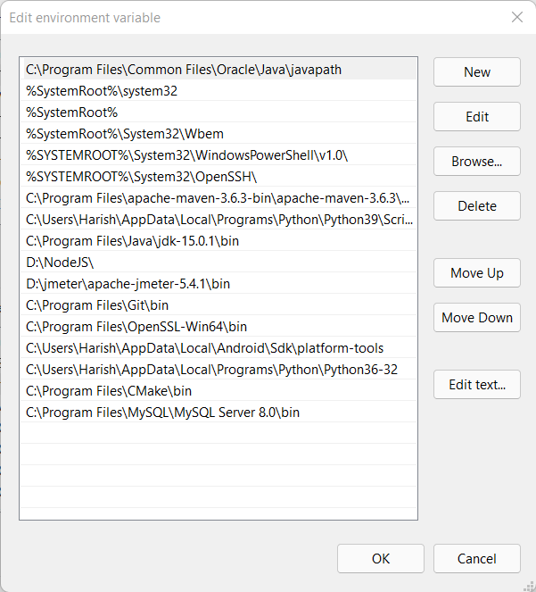

Step 9: Click on “Ok” of all the 3 windows related to system environment variables.

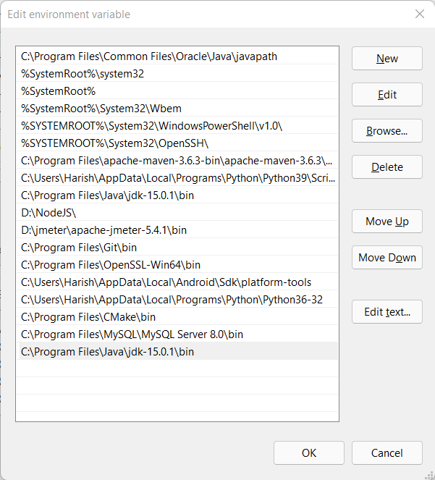

**Note**- To cross verify that java is installed properly, open a command prompt and type java

–version And javac –version as shown in the below screenshot.

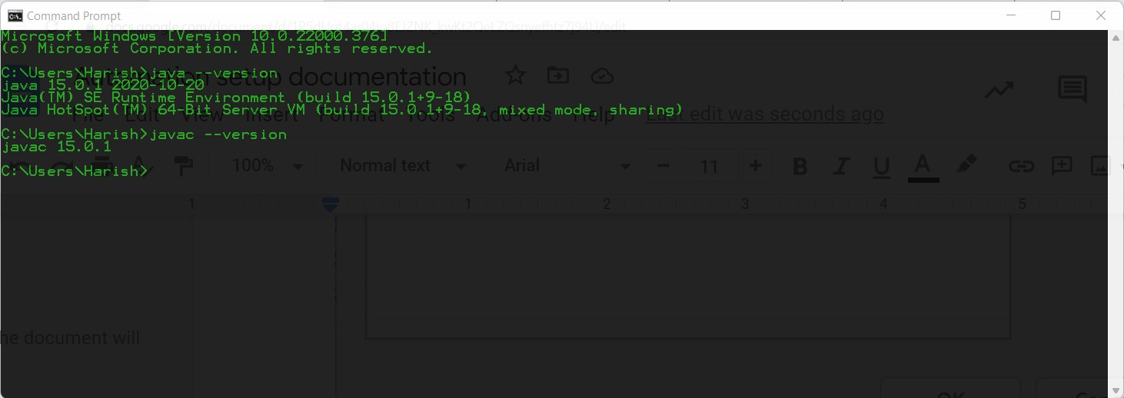

# Eclipse Installation:

Step 1: Goto : <https://www.eclipse.org/downloads/>

Click on Download x85_64, after Downloading. Open the Eclipse Installer



Step 2: Select Eclipse IDE for Java Developers, wait for it to download.

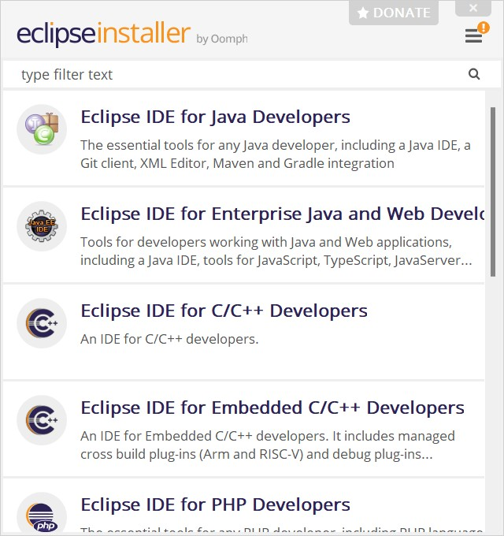

Step 3: Click on Launch.

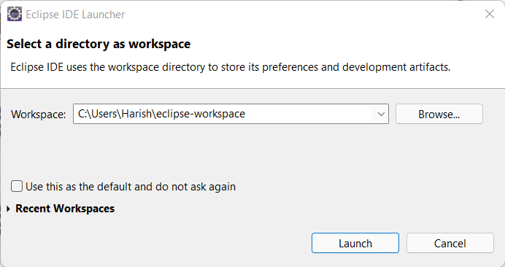

Step4: After clicking on Launch below the welcome window will appear with the interface as shown below.

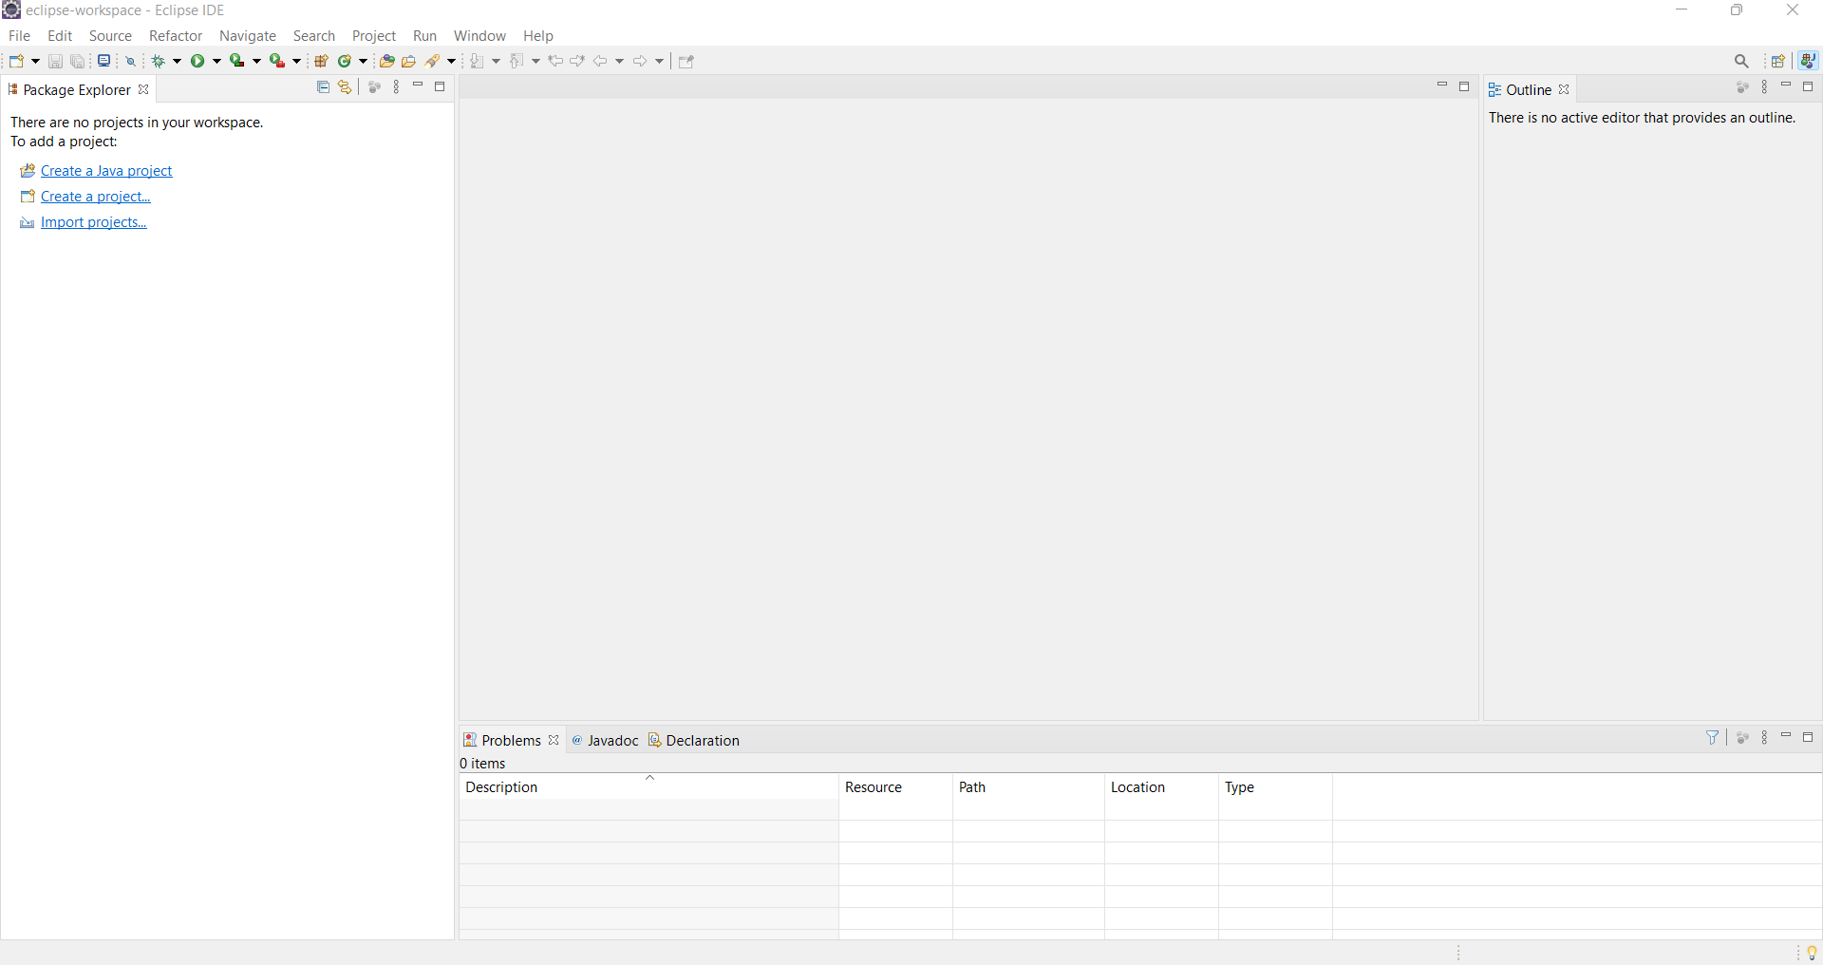

TestNG Plugin Installation:

Step 5: Click on Help and then Eclipse Marketplace

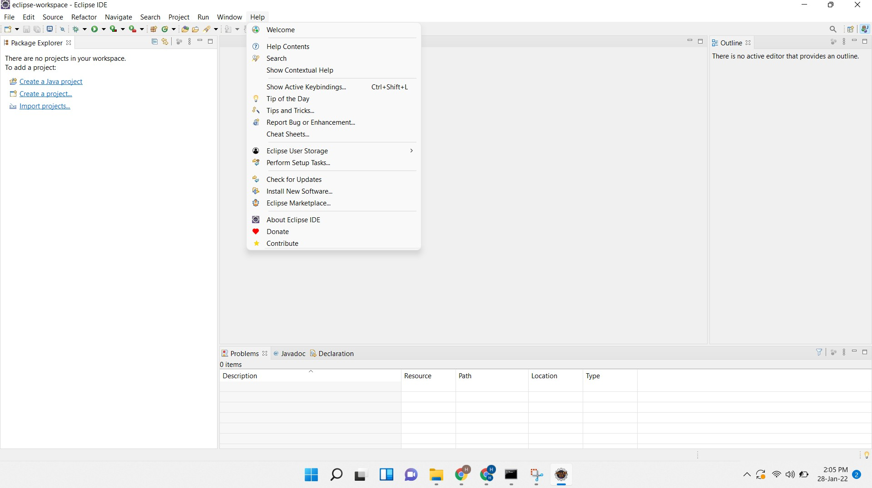

Step 6: Select Eclipse Marketplace.

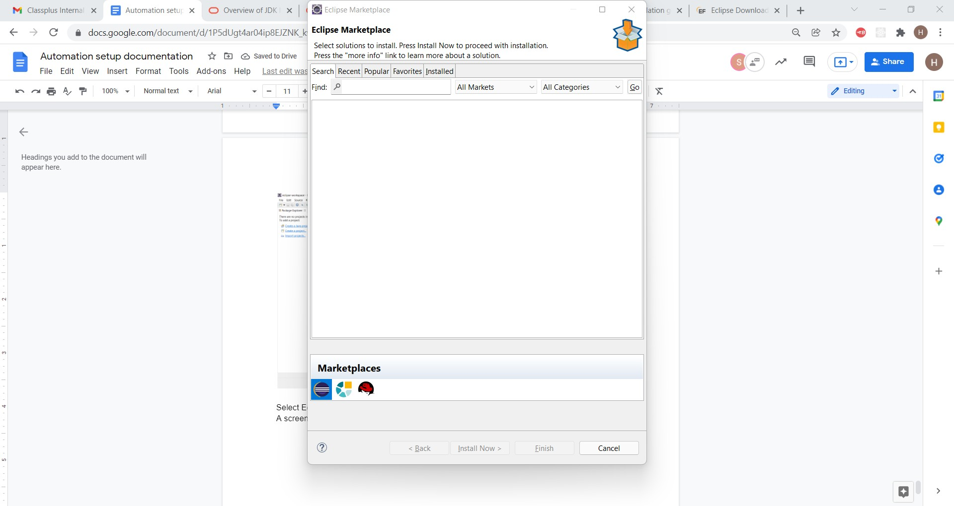

Step7: Search for TestNG in search bar and click on GO

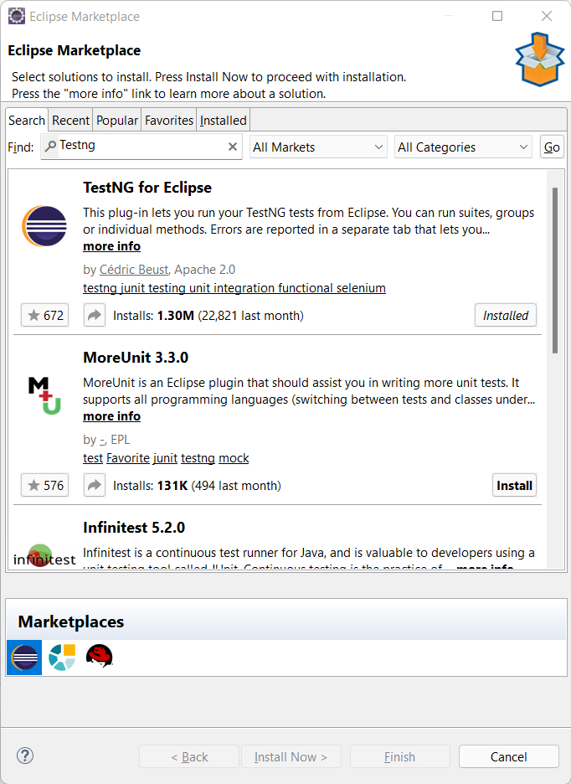Install TestNG for Eclipse plugin.

# Automation code checkout

Step 1: Go to “[h ttps://github.com/](https://github.com/)” Below window will appear

Step 2: Sign-in

Enter the Username and Password and click on Sign in

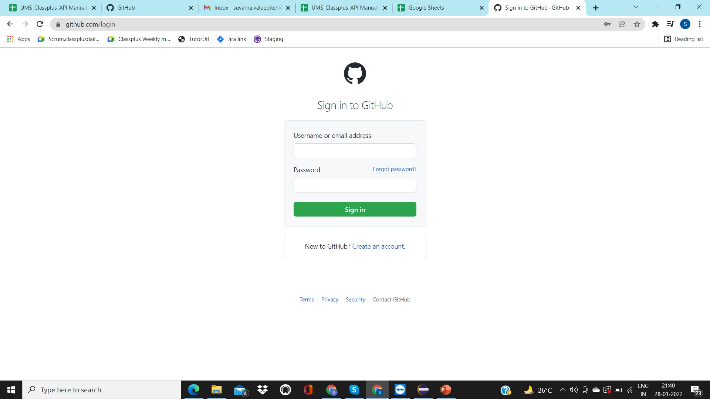

Step 3: Click on Repositories

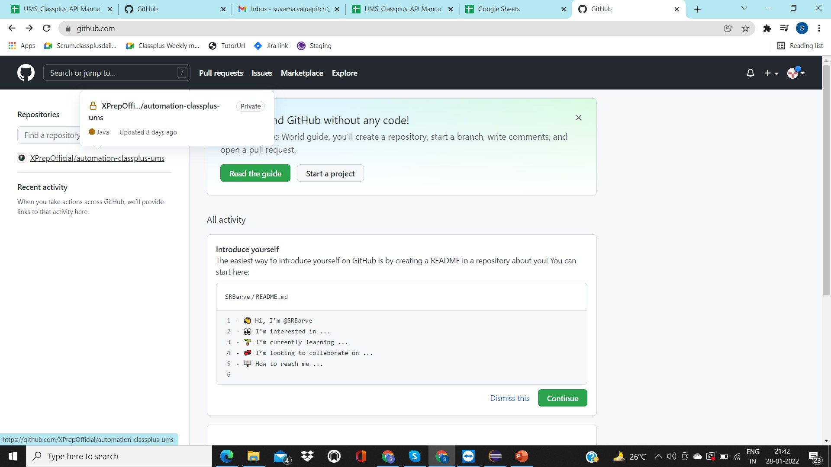

Step 4: Click on Code

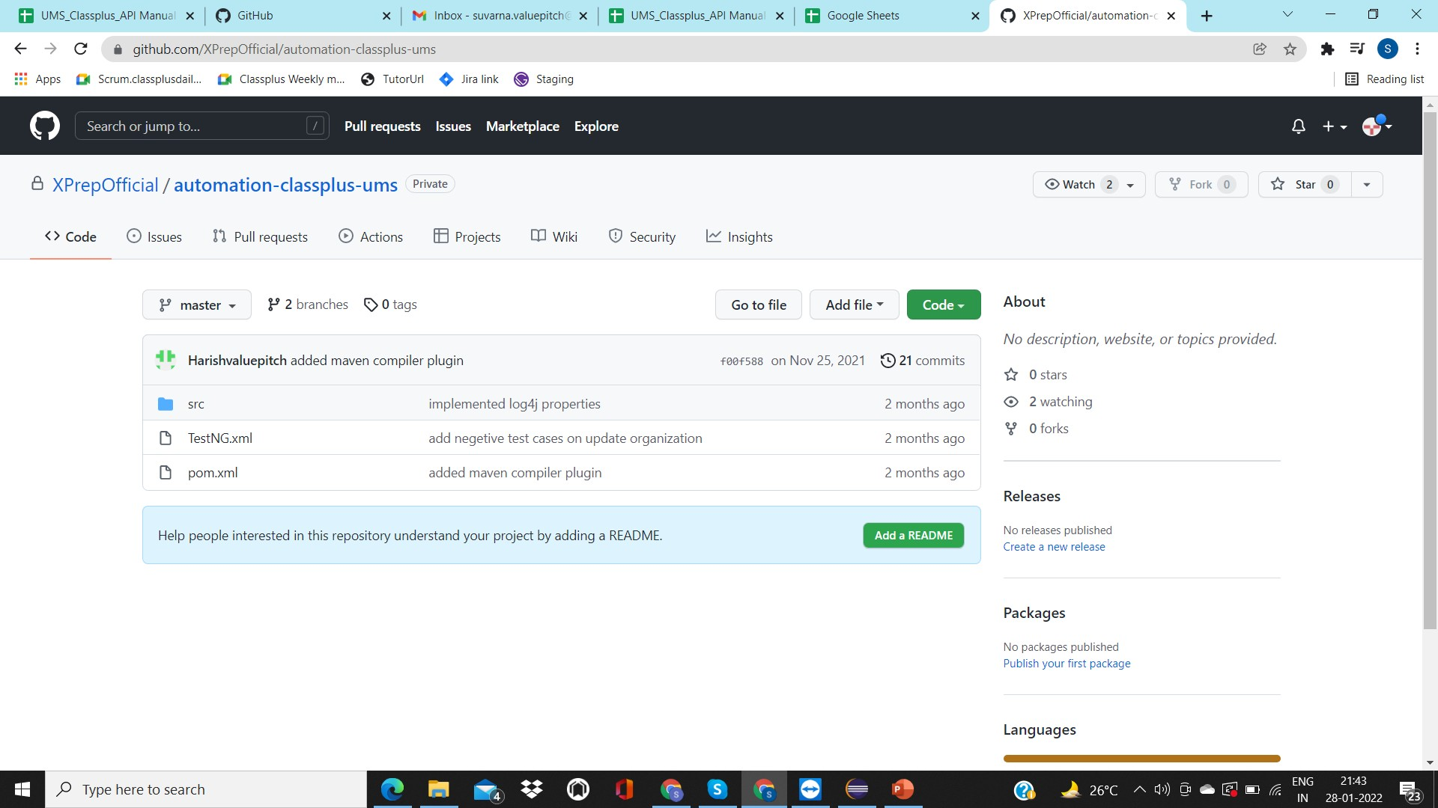

Step 5: Copy the the link

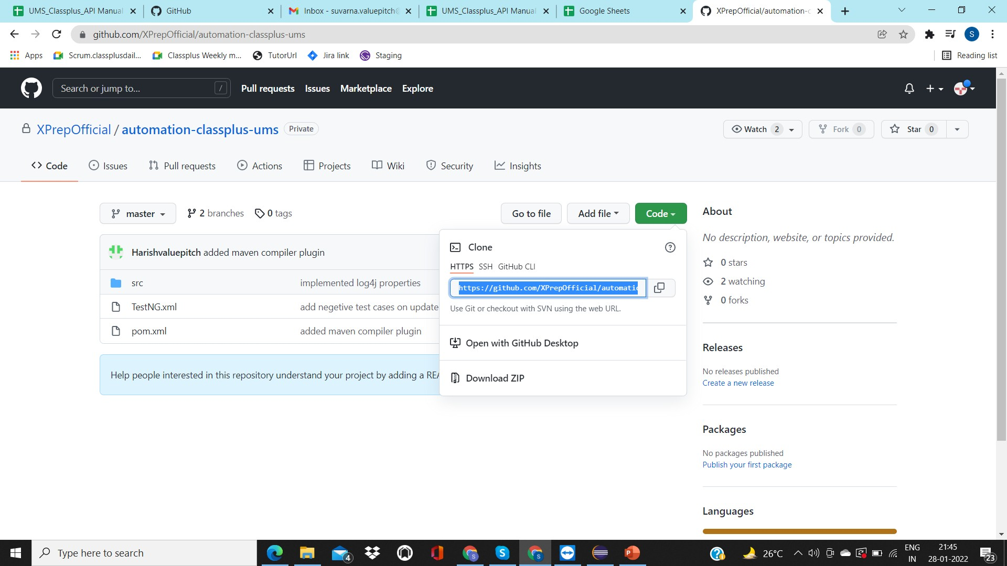

Step 6: Open the command prompt enter the below command Choose any repo which you would like to setup the project.

git clone <https://github.com/XPrepOfficial/automation-classplus-ums.git>

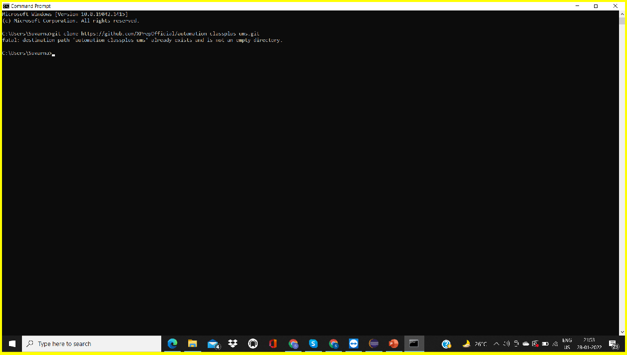

# Automation project setup in eclipse

Step1: Open the Eclipse and click on File>Import

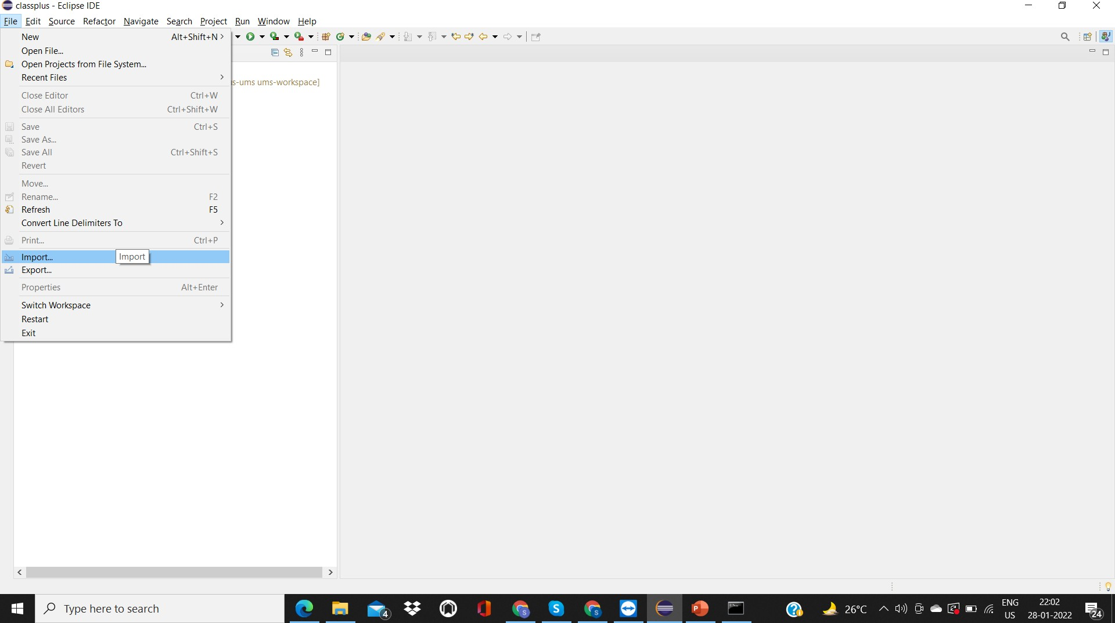

Step2:Select Existing Maven project and click on “Next”

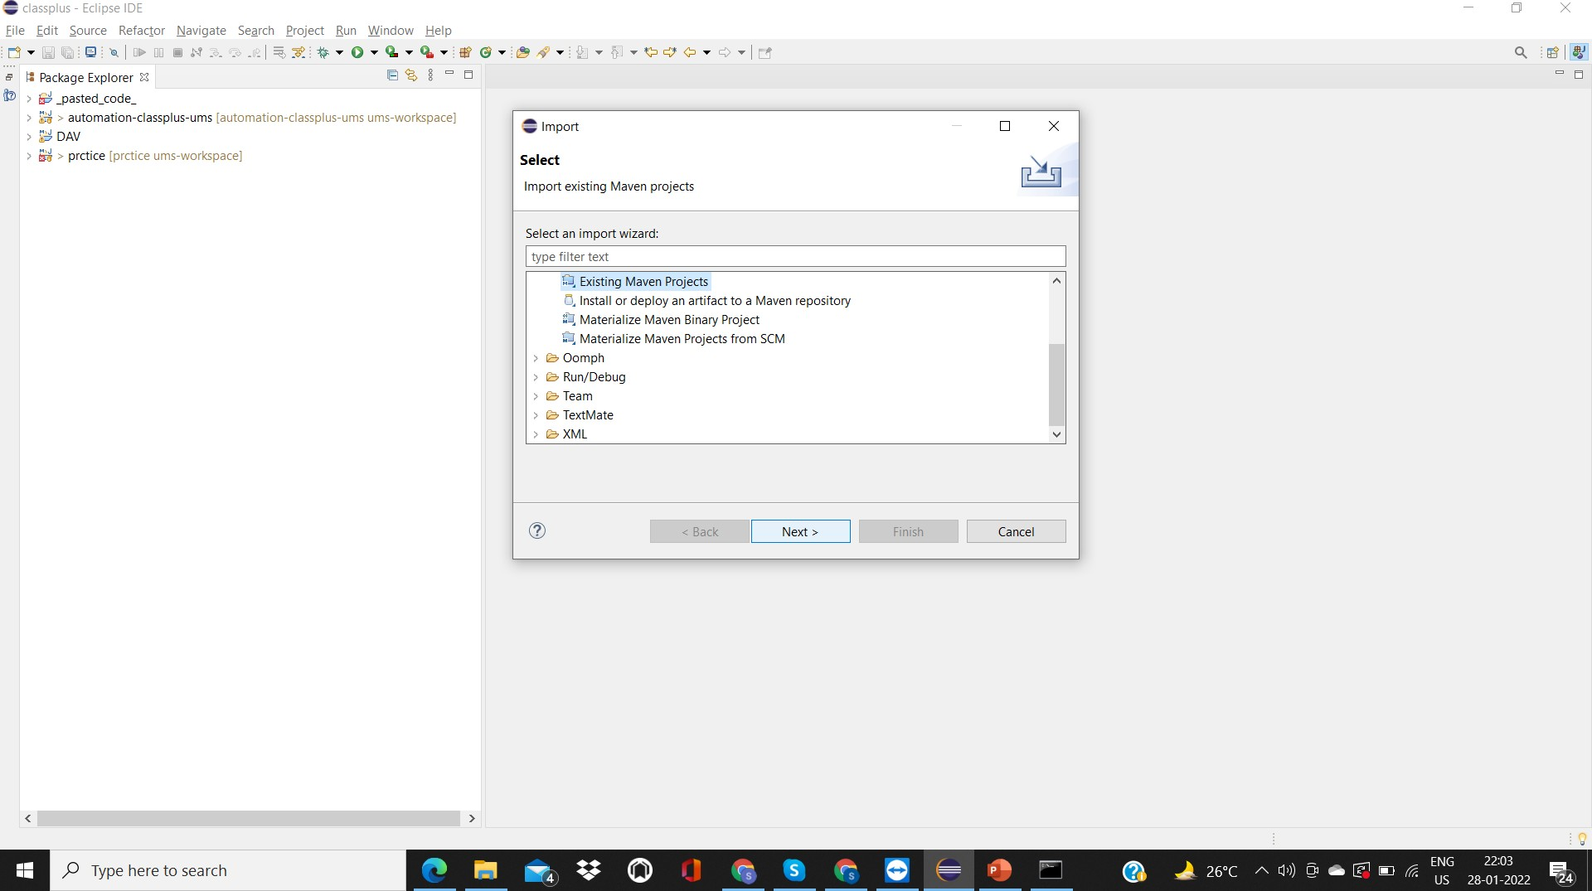

Step3: Click on Browse

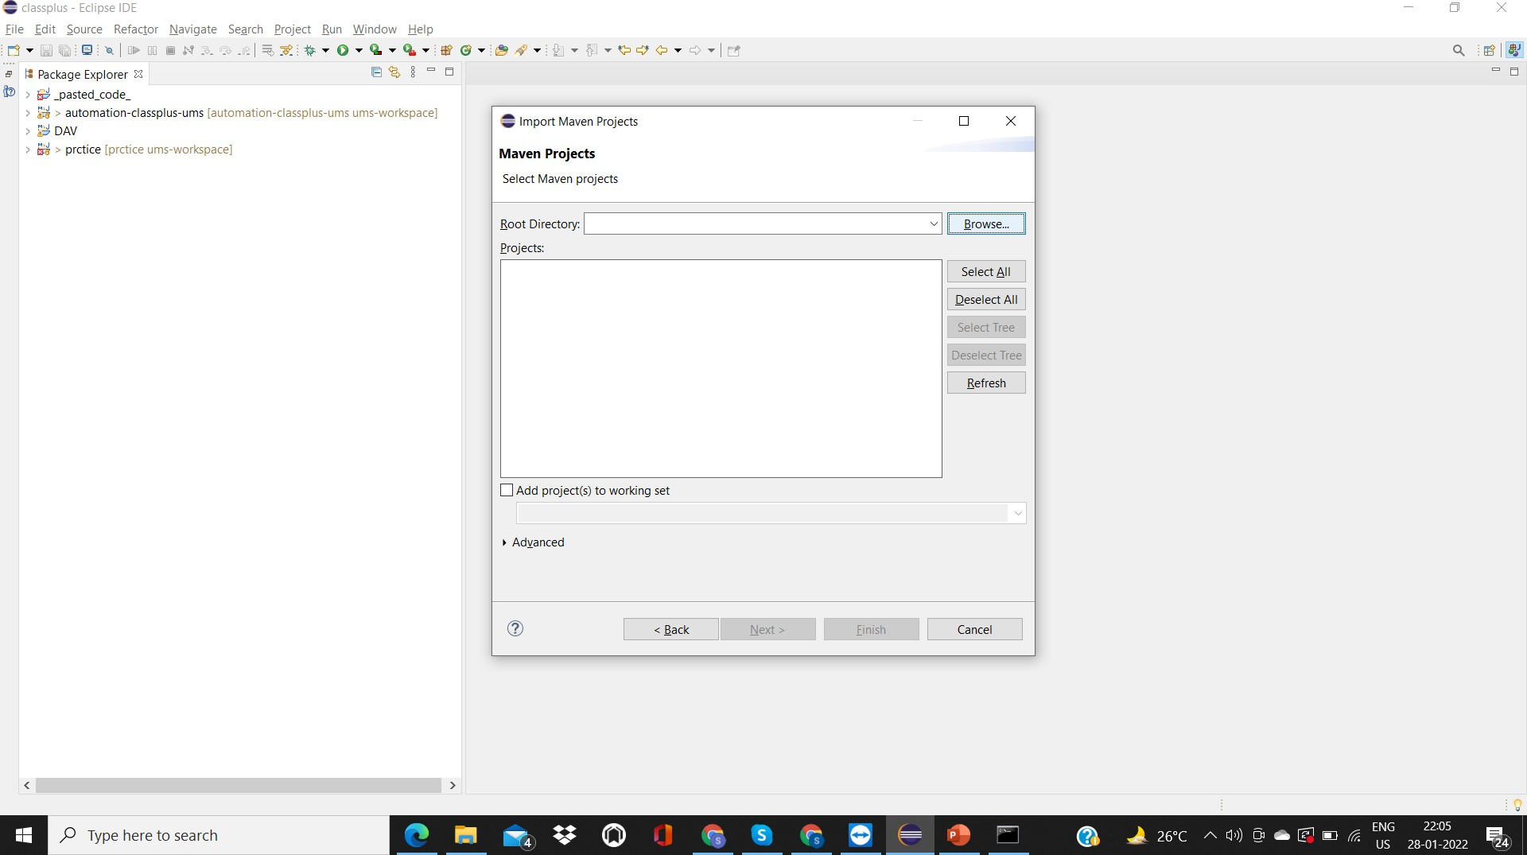

Step 4: Go to the project parent location where we have clone project and click on Select Folder

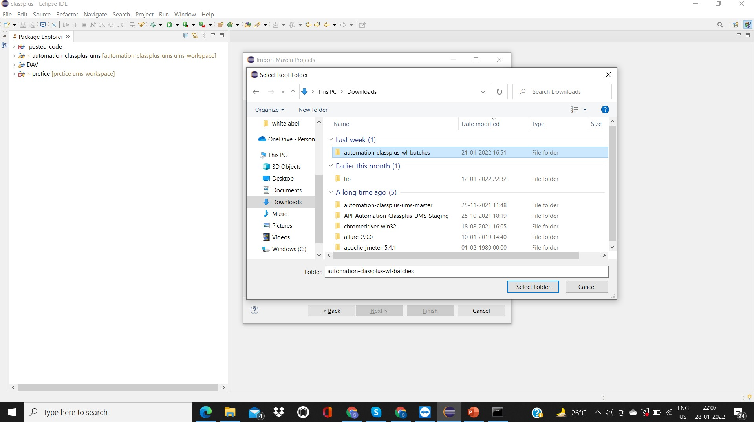

Step5: Click on “Finish”

We can see the imported file to left side on the screen i.e. Package Explore

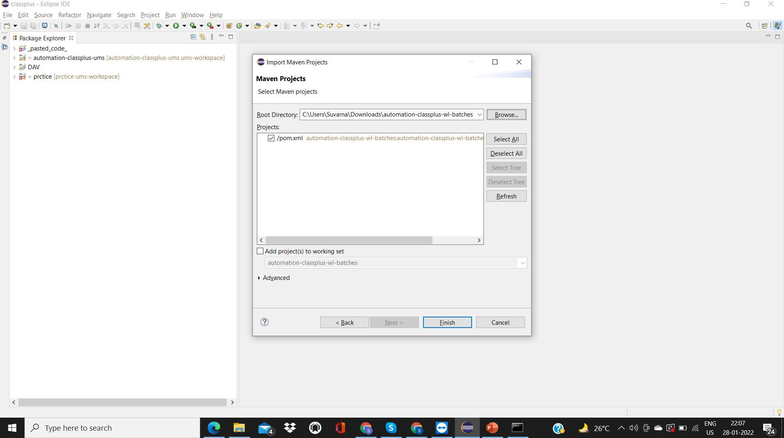

# How to run Automation code

Step1: Open the Project and click on pom.xml

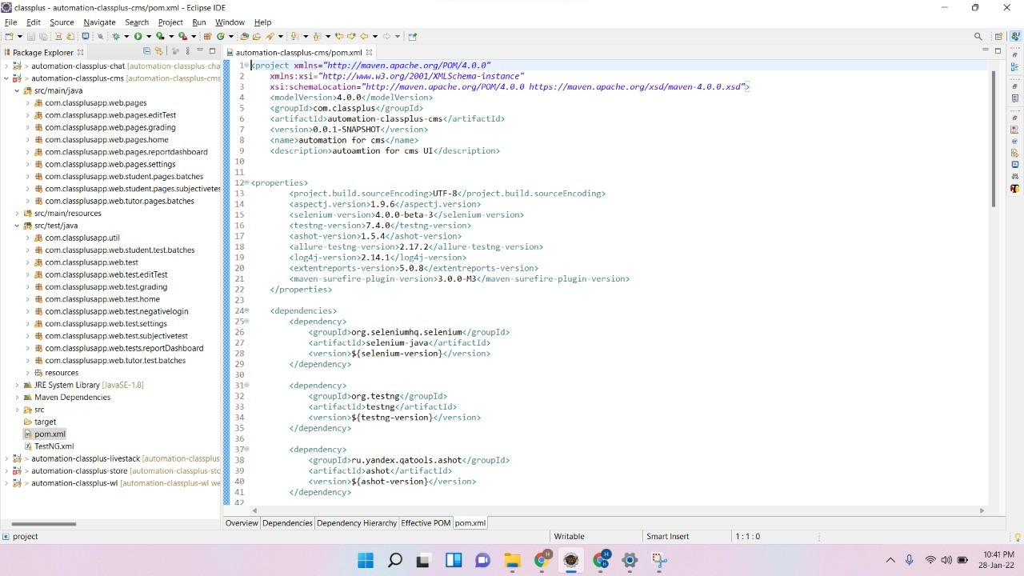

Step 2: Right click on Run As

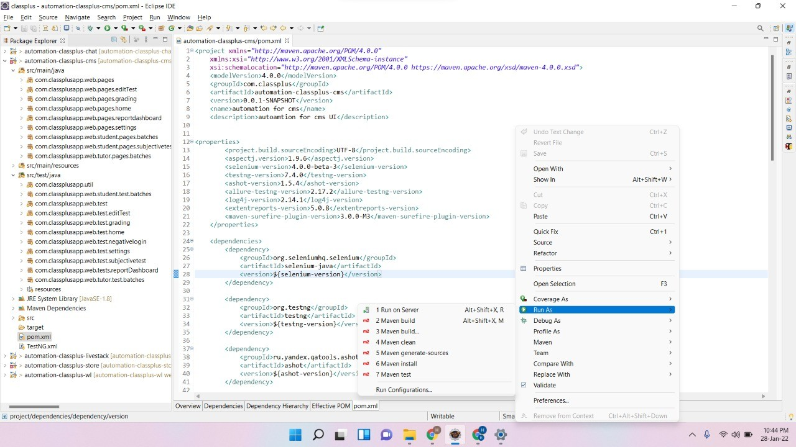

Step 3: Click on maven Install

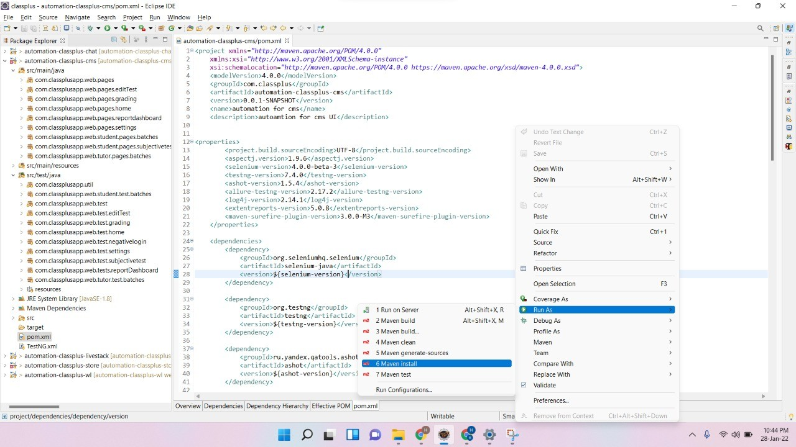

Step 4: Execution started